Nursery
 | Mental  Health  9.00am | Gross Motor Skills  9.30am | Handwriting  9.45 am | Maths  10-10.30am | Phonics  10.30-11.00am | UW/EAD  11.00-11.30am | Story Time  11.30-11.45am)
Monday | Mindfulness  Everyday |  | Video  Activity sheet  Letter formation mat | Nursery Rhymes  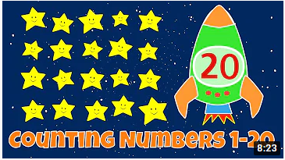  Practise counting to 20 every day. Make some number cards from 1-10 and help your child to learn their numbers. If they already recognise them they could use them to count out toys to match each number.  This week we are going to focus on counting and recognising number 7. Try counting out 7 toys, forks, pencils, sweets from a larger group.  Click here for some other ideas. And here's a counting poster. How many birds/bunnies/elves can you see?  Here are two fun episodes of the Numberblocks.  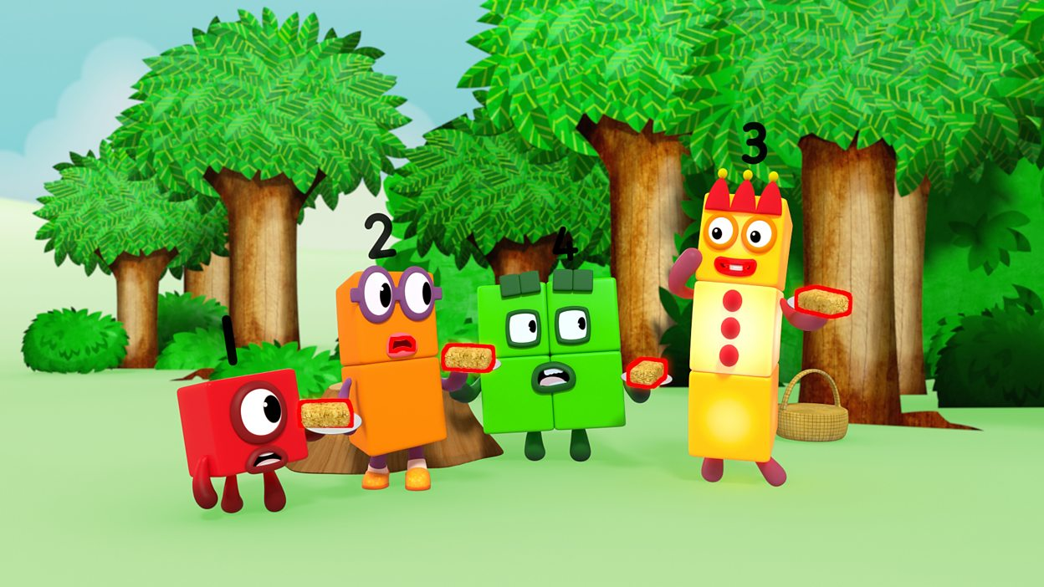  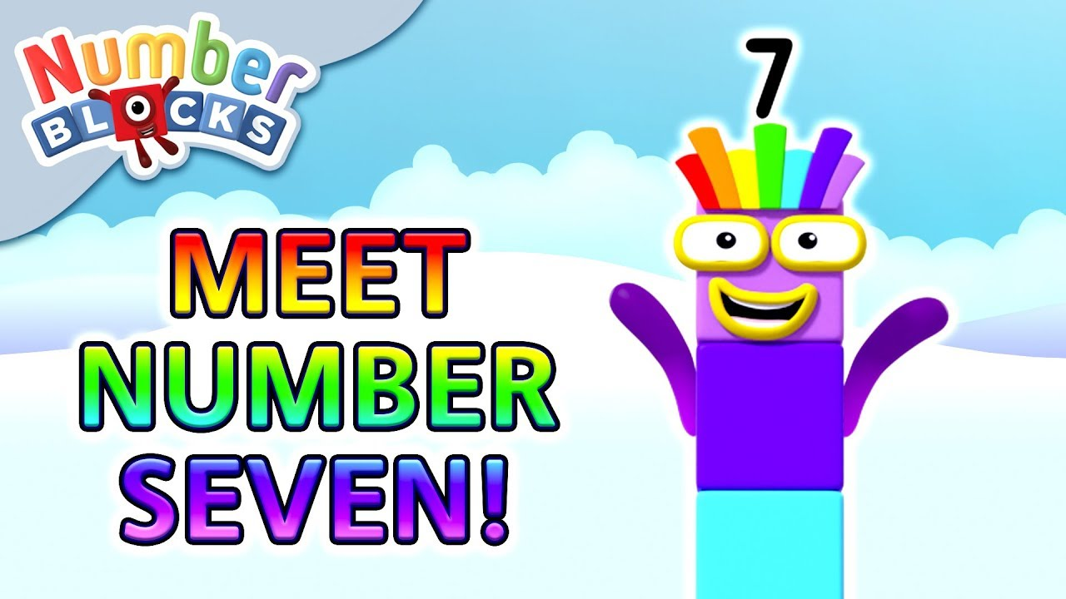 | Here's a fun phonics activity to play this week. Fill a collection of socks with items from around your home that have different sounds. The picture below has some ideas. Then shake them and see if you can guess what's inside! Can you describe the sound? Is it a loud sound or a quiet sound, a rattling sound or a tapping sound. This game is good for developing those super language skills as well as your listening skills!  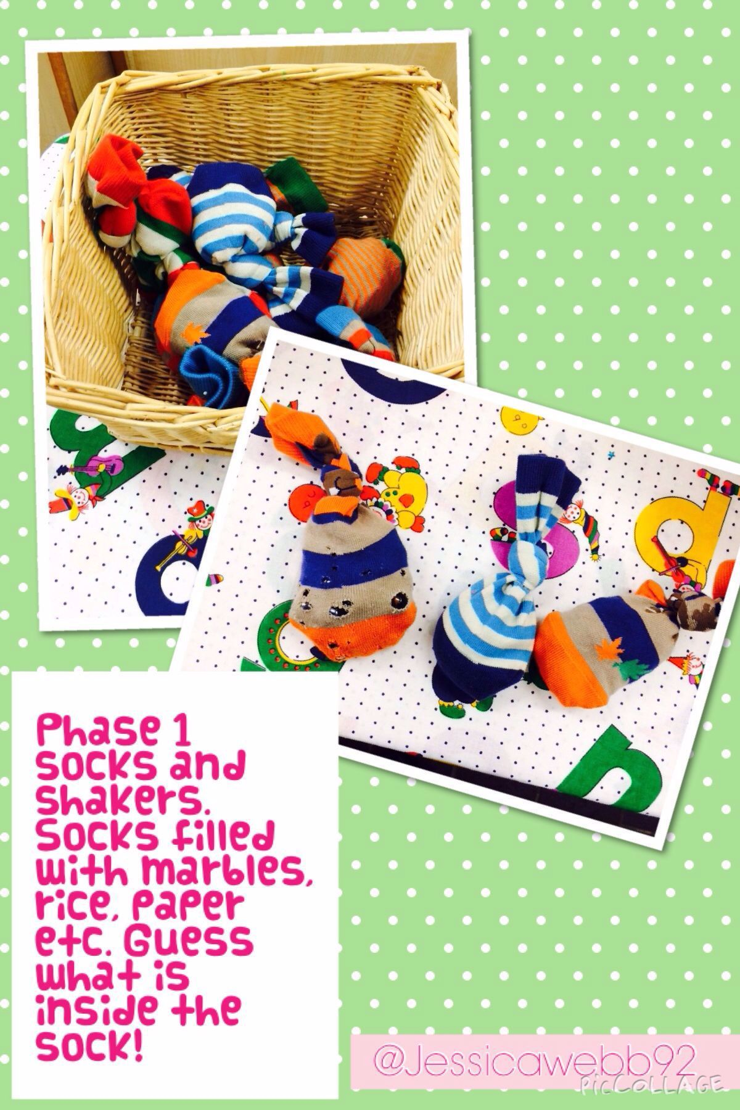  Take a look at the story 'Dear Zoo'. Can you make the animal noises? What sound does each of the animals begin with? Can you point to the j-i-raffe? Don't forget mums and dad's, even though giraffe begins with a 'g' the sound it makes is actually 'j' and it's those sounds that are important when we are learning to read. I spy with my little eye, an animal beginning with 's', 'f'.  If you feel your child is ready to begin to learn some letter sounds, check out the links below. This week we will learn the 's' sound. In Nursery we concentrate on one new sound per week to give the children lots of time to learn and practise their new skill. Watch the video below over a couple of days. Search around your house for things beginning with 's' and practise drawing 's'. We use sand, salt etc and our fingers to draw the 's' sound. | UW- Lesson 1  PSED-Same & different lesson 1  PSED-Same & different lesson 2  PSED-Same and different lesson 3  PSED- Same & different lesson 4 | 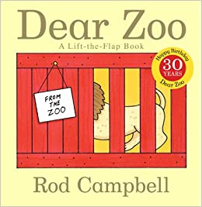
Tuesday
Wednesday
Thursday

Fri  Family fun! |  | Cooking  Pitta Pizza Video  Jam Tarts Recipe | Board game  Play a game with your family. | Street Dance |  | Roots to Fruits

Reception
 | PE  9.00 | Literacy  The Gingerbread Man  9.30 – 10.00 | Phonics games  10.00 | Maths  Measurement  11.00-  11.30am | Maths Games  11.30 – 12.00 | Phonics  1.00 – 1.10 | Reading  1.10 – 1.30 | Other  2 – 2.30 | Story Time
Mon | PE With  Joe Wicks  Cosmic Kids Yoga | Lesson 1 | Read and match | Lesson 1 | Subtraction | Lesson 1 | Lesson 1 | Music 1  Music 2  Music 3  UTW 1  UTW 2  UTW 3 | Love Monster and the Perfect Present  Even Superheroes Make Mistakes  Copy Cat
Tues |  | Lesson 2 |  | Lesson 2 |  | Lesson 2 | Lesson 2
Wed |  | Lesson 3 |  | Lesson 3 |  | Lesson 3 | Lesson 3
Thurs |  | Lesson 4 |  | Lesson 4 |  | Lesson 4 | Lesson 4
Fri |  | Lesson 5 |  | Lesson 5 |  | Lesson 5 | Lesson 5

Year 1 – wb 29.03.21
Day | 9:15-9:30mins | 9:30-10:15 | 10:15-10:45 | BREAK | 11:00-11:45 |  | 11:45-12:15 | 12:15-1:00 | 1:00-1:30 | 1:30-2:15 | 2:15-2:45
Monday | TTRS | Maths VIDEO | Phonics Play  EDSHED |  | English VIDEO |  | Phonics VIDEO | LUNCH | MYON | RE VIDEO | PE /fitness  Joe Wicks
Tuesday |  | Maths VIDEO |  |  | English VIDEO |  | Phonics VIDEO |  |  | Science VIDEO | PE /fitness  Joe Wicks
Wednesday |  | Maths VIDEO |  |  | English VIDEO |  | Phonics VIDEO |  |  | Geography VIDEO | PE /fitness  Joe Wicks
Thursday |  | Maths VIDEO |  |  | English VIDEO |  | Phonics VIDEO |  |  | Music VIDEO | PE /fitness  Joe Wicks
Friday |  | Maths VIDEO |  |  | English VIDEO | Phonics VIDEO |  |  |  | ART | PE /fitness  Joe Wicks

Year 2
Day | 9:00-9:15 | 9:15-30am | 9.30-10:30am | 10.30-10.45 | 10.45-11.45am | 11.45-12.00 | 12:00-  1.15pm | 1.15-2.15pm | P2.30-3:00pm | 2:30-3:00pm
Monday | TTRS | Spelling Shed | Maths  Multiplication and division | Break | English: newspaper reports | Reading: Myon/  Quizzes | Lunch | Science | PE fitness | Story time
Tuesday |  |  | Maths  Multiplication and division |  | English: newspaper reports | Reading: Myon/  Quizzes |  | Art/DT | PE fitness
Wednesday |  |  | Maths  Multiplication and division |  | English newspaper reports | Reading: Myon/  Quizzes |  | Geography | PE fitness
Thursday |  |  | Maths Multiplication and division |  | English newspaper reports | Reading: Myon/  Quizzes |  | Music | PE fitness
Friday |  |  | Maths Multiplication and division |  | English newspaper reports | Reading: Myon/  Quizzes |  | RE/PSHE | PE fitness

Year 3 Timetable
Day | 9:00 - 9:30 | 9:30 - 10:15  Maths | 10:15 - 10:30 | 10:30 - 10:45 | 10:45 - 11:45  English | 11:45 – 12:15  Reading | 12:15 1:00 | 1:00 - 1:30 | 1:30 – 2:00  PE | 2:00 – 3:00  Topic
Monday | TT Rockstars | Time  Maths Lesson 1 | Break | EdShed | Non-chronological report  English Lesson 1 | Reading 1  Link  Activity 1 | Lunch | MyON | PE with Joe Wicks | History  RTF  Dance  Science
Tuesday |  | Time  Maths Lesson 2 |  |  | Non-chronological report  English Lesson 2 | Reading 2  Link  Activity 2
Wednesday |  | Time  Maths Lesson 3 |  |  | Non-chronological report  English Lesson 3 | Reading 3  Link  Activity 3
Thursday |  | Time  Maths Lesson 4 |  |  | Non-chronological report  English Lesson 4 | Reading 4  Link  Activity 1
Friday |  |  |  |  | Easter holidays

Year 4 Timetable
Day | 9:00 - 9:30 | 9:30 - 10:15  Maths | 10:15 - 10:30 | 10:30 - 10:45 | 10:45 - 11:45  English | 11:45 – 12:15  Reading | 12:15 1:00 | 1:00 - 1:30 | 1:30 – 2:00  PE | 2:00 – 3:00  Topic
Monday | TT Rockstars | Solving Problems  Maths Lesson 1 | Break | EdShed | Newspaper Report  English Lesson 1 | Write a Recount of what happened in the clip.  Reading Link | Lunch | MyON | PE with Joe Wicks | What was life like in Viking Britain  History  RTF  Dance  Science
Tuesday |  | Solving Problems  Maths Lesson 2 |  |  | Newspaper Report  English Lesson 2 | Write a paragraph on how the girl was feeling.  Reading Link
Wednesday |  | Solving Problems  Maths Lesson 3 |  |  | Newspaper Report  English Lesson 3 | Explain what you think the girl and boy are thinking about the umbrella.  Reading Link
Thursday |  | Solving Problems  Maths Lesson 4 |  |  | Newspaper Report  English Lesson 4 | Write a diary entry for the umbrella.  Reading Link
Friday |  | Solving Problems  Maths Lesson 5 |  |  | Newspaper Report  English Lesson 5 | Think of your own umbrella adventure.  Reading Link

Year 5
 | 9.00-9:30am | Maths | BREAK- 10:30-10:45 | English |  | LUNCH 12:00-13;00 |  | TOPIC | PE
M | My On | Maths Lesson Video 1  Worksheet link |  | To engage with the context of the 'How to Train your dragon' narrative | TT RS |  | EDShed | DT - Cooking and nutrition: celebrating culture and seasonality | Joe Wicks PE Lesson
T |  | Maths Lesson Video 2  Worksheet link |  | To investigate suffixes: Plurals |  |  |  | Drama - Exploring narrative poetry through Drama | Joe Wicks PE Lesson
W |  | Maths Lesson Video 3  Worksheet link |  | To explore simple and compound sentences |  |  |  | French- C'est moi! | Joe Wicks PE Lesson
T |  | Maths Lesson Video 4  Worksheet link |  | To identify the C and S features of an opening scene |  |  |  | Geography - Why do geographers do fieldwork? | Joe Wicks PE Lesson

Year 6
 | PE  (9.00am) | Own Reading  (9.30-10am) | Maths  (10-11.00am) | English  (11.00-12.00pm) | Spellings  (1.00 -1.15pm) | Times Tables (1.15-1.30pm) | Other
Monday | PE With Joe Wicks (PE with Joe) | Myon  (myON) | Subtrahend  (Link) | Engage with a text  (Link) | Spelling Shed (EdShed) | TT Rockstars  (Rockstars) | Roots to Fruits  (RTF)  Street Dance (Dance)  Art: Experiment with fine line drawing  (Link)  Science: Animal kingdoms  (Link)  Geography: Where are the Earth’s Biomes?  (Link)  RE: Christian celebrations  (Link)
Tuesday |  |  | Explore problems  (Link) | Analyse character  (Link)
Wednesday |  |  | Balance equations  (Link) | Analyse a text  (Link)
Thursday |  |  | Balance equations  (Link) | Analyse themes  (Link)
Friday |  |  | Easter holidays | Easter holidays

