Nursery
 | PE  9.00am | Gross Motor Skills  9.30am | Handwriting  9.45 am | Maths  10-10.30am | Phonics  10.30-11.00am | UW/EAD  11.00-11.30am | Story Time  11.30-11.45am)
Monday | PE With Joe Wicks | 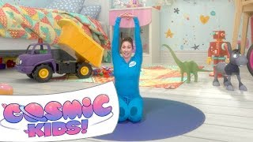 | Video  Activity sheet | Nursery Rhymes  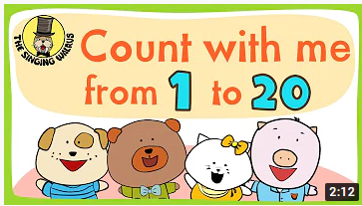  Practise counting to 20 every day. Make some number cards from 1-10 and help your child to learn their numbers. If they already recognise them they could use them to count out toys to match each number.  Look at the page Scavenger Hunt link below to count objects up to 5.  Scavenger Hunt | 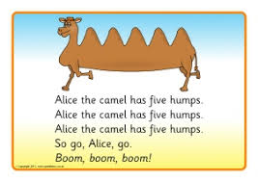  Practise hearing the beginning sound in words this by clicking on the link below. Choose a different one every day. If prompted to sign in use Login: username: jan21  password: home.  Practise writing your name every day using your name card. If you have lost it, please ask mum or dad to write it out in big letters for you to copy. Please help your child to write their name with a capital letter at the beginning and lower case letters for the rest. Click on the link below to see how to help your child form their letters correctly.  Letter formation mat | People who help us Lesson 1 | 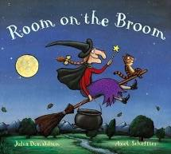  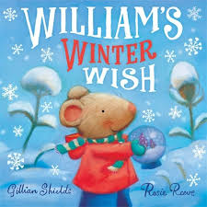  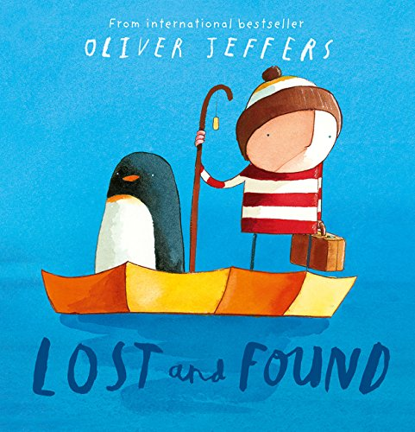
Tuesday
Wednesday
Thursday

Fri  Family fun! |  | Cooking  Choose 1 from the 2 recipes sent. | Board game  Play a game with your family. | Street Dance |  | Roots to Fruits

Reception
Reception Weekly Timetable 22/3/2021
 | PE  9.00 | Literacy  Goldilocks and the 3 bears  9.30 – 10.00 | Phonics games  10.00 | Maths  Measurement  11.00-  11.30am | Maths Games  11.30 – 12.00 | Phonics  1.00 – 1.10 | Reading  1.10 – 1.30 | Other  2 – 2.30 | Story Time
Mon | PE With  Joe Wicks  Cosmic Kids Yoga | Lesson 1 | Read and match | Lesson 1 | Comparing Weight  Comparing Size | Lesson 1 | Lesson 1 | Music 1  Music 2  Music 3  UTW 1  UTW 2  UTW 3 | Room on the Broom – read by Ms Sidhu  The Way Back Home  I wish I’d been born a Unicorn
Tues |  | Lesson 2 |  | Lesson 2 |  | Lesson 2 | Lesson 2
Wed |  | Lesson 3 |  | Lesson 3 |  | Lesson 3 | Lesson 3
Thurs |  | Lesson 4 |  | Lesson 4 |  | Lesson 4 | Lesson 4
Fri |  | Lesson 5 |  | Lesson 5 |  | Lesson 5 | Lesson 5

Year 1 – wb 22.03.21
Day | 9:15-9:30mins | 9:30-10:15 | 10:15-10:45 | BREAK | 11:00-11:45 |  | 11:45-12:15 | 12:15-1:00 | 1:00-1:30 | 1:30-2:15 | 2:15-2:45
Monday | TTRS | Maths VIDEO | Phonics Play  EDSHED |  | English VIDEO |  | Phonics VIDEO | LUNCH | MYON | RE VIDEO | PE /fitness  Joe Wicks
Tuesday |  | Maths VIDEO |  |  | English VIDEO |  | Phonics VIDEO |  |  | Science VIDEO | PE /fitness  Joe Wicks
Wednesday |  | Maths VIDEO |  |  | English VIDEO |  | Phonics VIDEO |  |  | Geography VIDEO | PE /fitness  Joe Wicks
Thursday |  | Maths VIDEO |  |  | English VIDEO |  | Phonics VIDEO |  |  | Music VIDEO | PE /fitness  Joe Wicks
Friday |  | Maths VIDEO |  |  | English VIDEO | Phonics VIDEO |  |  |  | ART | PE /fitness  Joe Wicks

Year 2
Day | 9:00-9:15 | 9:15-30am | 9.30-10:30am | 10.30-10.45 | 10.45-11.45am | 11.45-12.00 | 12:00-  1.15pm | 1.15-2.15pm | P2.30-3:00pm | 2:30-3:00pm
Monday | TTRS | Spelling Shed | Maths  Multiplication and division | Break | English: newspaper reports | Reading: Myon/  Quizzes | Lunch | Science | PE fitness | Story time
Tuesday |  |  | Maths  Multiplication and division |  | English: newspaper reports | Reading: Myon/  Quizzes |  | Art/DT | PE fitness
Wednesday |  |  | Maths  Multiplication and division |  | English newspaper reports | Reading: Myon/  Quizzes |  | Geography | PE fitness
Thursday |  |  | Maths Multiplication and division |  | English newspaper reports | Reading: Myon/  Quizzes |  | Music | PE fitness
Friday |  |  | Maths Multiplication and division |  | English newspaper reports | Reading: Myon/  Quizzes |  | RE/PSHE | PE fitness

Year 3 Timetable
Day | 9:00 - 9:30 | 9:30 - 10:15  Maths | 10:15 - 10:30 | 10:30 - 10:45 | 10:45 - 11:45  English | 11:45 – 12:15  Reading | 12:15 1:00 | 1:00 - 1:30 | 1:30 – 2:00  PE | 2:00 – 3:00  Topic
Monday | TT Rockstars | Time  Maths Lesson 1 | Break | EdShed | Non-chronological report  English Lesson 1 | Reading 1  Link  Activity 2 | Lunch | MyON | PE with Joe Wicks | History  RTF  Dance  Science
Tuesday |  | Time  Maths Lesson 2 |  |  | Non-chronological report  English Lesson 2 | Reading 2  Link  Activity 3
Wednesday |  | Time  Maths Lesson 3 |  |  | Non-chronological report  English Lesson 3 | Reading 3  Link  Activity 1
Thursday |  | Time  Maths Lesson 4 |  |  | Non-chronological report  English Lesson 4 | Reading 4  Link  Activity 2
Friday |  | Time  Maths Lesson 5 |  |  | Non-chronological report  English Lesson 5 | Reading 5  Link  Activity 3

Year 4 Timetable
Day | 9:00 - 9:30 | 9:30 - 10:15  Maths | 10:15 - 10:30 | 10:30 - 10:45 | 10:45 - 11:45  English | 11:45 – 12:15  Reading | 12:15 1:00 | 1:00 - 1:30 | 1:30 – 2:00  PE | 2:00 – 3:00  Topic
Monday | TT Rockstars | Time  Maths Lesson 1 | Break | EdShed | Newspaper Report  English Lesson 1 | Write a Recount of what happened in the clip.  Reading Link | Lunch | MyON | PE with Joe Wicks | Viking Traders and Explorers  History  RTF  Dance  Science
Tuesday |  | Converting  Maths Lesson 2 |  |  | Newspaper Report  English Lesson 2 | Write a paragraph on how the pigeon might feel.  Reading Link
Wednesday |  | Converting  Maths Lesson 3 |  |  | Newspaper Report  English Lesson 3 | Explain what you think the person is thinking about the pigeon.  Reading Link
Thursday |  | Converting  Maths Lesson 4 |  |  | Newspaper Report  English Lesson 4 | Write a diary entry for the pigeon.  Reading Link
Friday |  | Converting  Maths Lesson 5 |  |  | Newspaper Report  English Lesson 5 | Think of your own pigeon adventure.  Reading Link

Year 5
Day | 9:00-9:15 | 9:15-30am | 9.30-10:15am | 10:15-10:30 | 10.30-10.45 | 10.45-11.30am | 11.30-12.00 | 12:00-12:45pm | 12:45-1.15pm | 1.15-2.00pm | 2.00-2:30pm | 2:30-3:00pm
Monday | Live Check in with Miss Coleman | TT Rockstars | Math Lesson 1 | BREAK | Edshed |  |  | LUNCH | MYON Reading |  |  | Story Time with Miss Coleman
Tuesday |  | TT Rockstars | Maths Lesson 2
Wednesday |  | TT Rockstars
Thursday |  | TT Rockstars
Friday  FAMILY LEARNING DAY |  | TT Rockstars | Recipes in the Family Learning Channel |  |  | Tim Peake: Ask an astronaut - BBC Bitesize |  |  |  | Dance  Get Active: https://vimeo.com/500686936/3592a5789d | RTFS with Adam  https://www.youtube.com/channel/UC_cDRN4OkglrwqIm_Wf5tSg | Email us the photos from your family learning day  Year5@oasisboulton.org

Year 6
 | PE  (9.00am) | Own Reading  (9.30-10am) | Maths  (10-11.00am) | English  (11.00-12.00pm) | Spellings  (1.00 -1.15pm) | Times Tables (1.15-1.30pm) | Other
Monday | PE With Joe Wicks (PE with Joe) | Myon  (myON) | Comparing strategies  (Link) | Plan a narrative  (Link) | Spelling Shed (EdShed) | TT Rockstars  (Rockstars) | Roots to Fruits  (RTF)  Street Dance (Dance)  Art: Experiment with layering  (Link)  Science: Fossils evidence  (Link)  Geography: What are Biomes?  (Link)  PSHE: I have a dream  (Link)  Mental Maths daily challenge  (Link)
Tuesday |  |  | Reduction  (Link) | ‘ie’ and ‘ei’  (Link)
Wednesday |  |  | Minuend and subtrahend  (Link) | Write a narrative  (Link)
Thursday |  |  | Minuend and subtrahend  (Link) | Narrative  (Link)
Friday |  |  | Solve fraction problems  (Link) | Narrative  (Link)

